|  |  |
| --- | --- |
|  | Telescope Project |

Memo

|  |  |
| --- | --- |
| To: | Troy Scevers |
| From: | Nathan Wiley |
| Date: | April 7, 2023 |
| Re: | Memo 1 |
|  |  |

This week I worked for 5 hours on getting the electronics inside the weatherproof box and planning this term out. Below is the timesheet for this week.



Since this term is going to be less intensive, I broke down the testing plans and testing to separate tasks for the motors, control program, and tracking. I included the most likely to be completed and most useful stretch goals in the schedule below.



A problem I am facing is that the 5mm shaft is slipping on the 3D printed 12 tooth small gear. Right now, I have fastened it with Gorilla Glue, but it isn’t very promising. That much torque may require epoxy or a metal alternative. The large gears are holding up well, although the movement of the chain isn’t as smooth as I’d hoped.

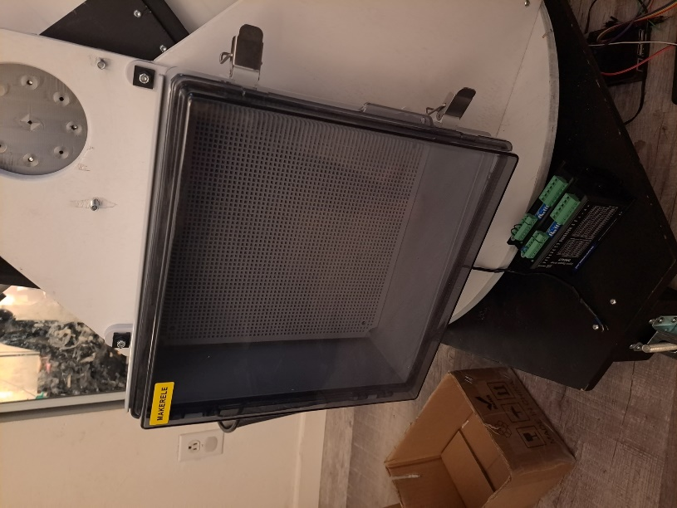Next week I plan to solder the circuit board to make a finalized product and start putting it all back together inside the weatherproof box. If I get that done next week, then in week 3 I can focus on the testing plans. However, since I have a lot of time between classes, I might start the testing plan next week.

Figure . Weatherproof Box

Below are a few pictures showing the installed weatherproof box.

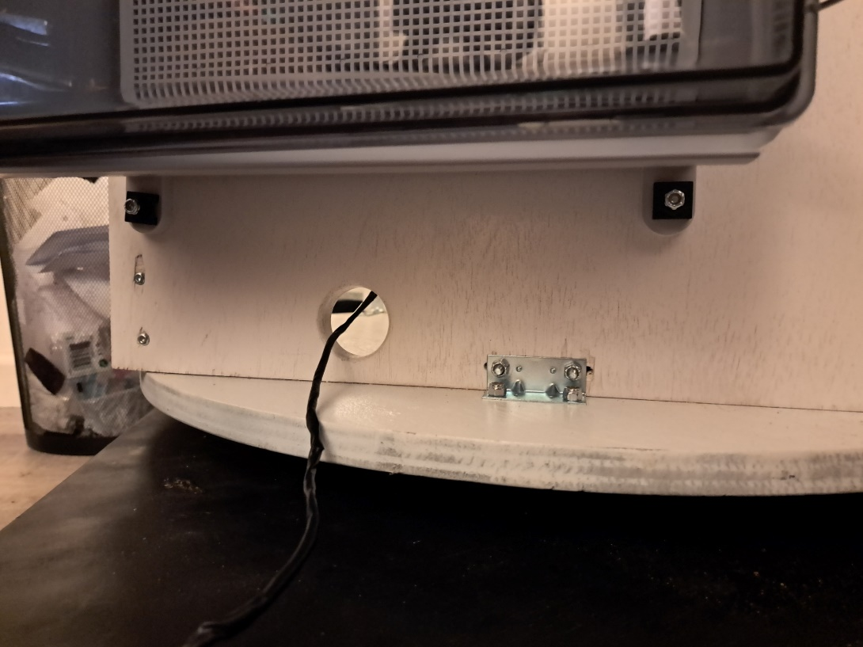

Figure . Hole drilled for wires to pass through.